IMT Worksheet 1

All your answers should be in a word document saved in a Git repository under your username. Submit your answers by sending a link to your git repository as a reply to your email.

Define the following concepts using screenshots and text:

* Repository

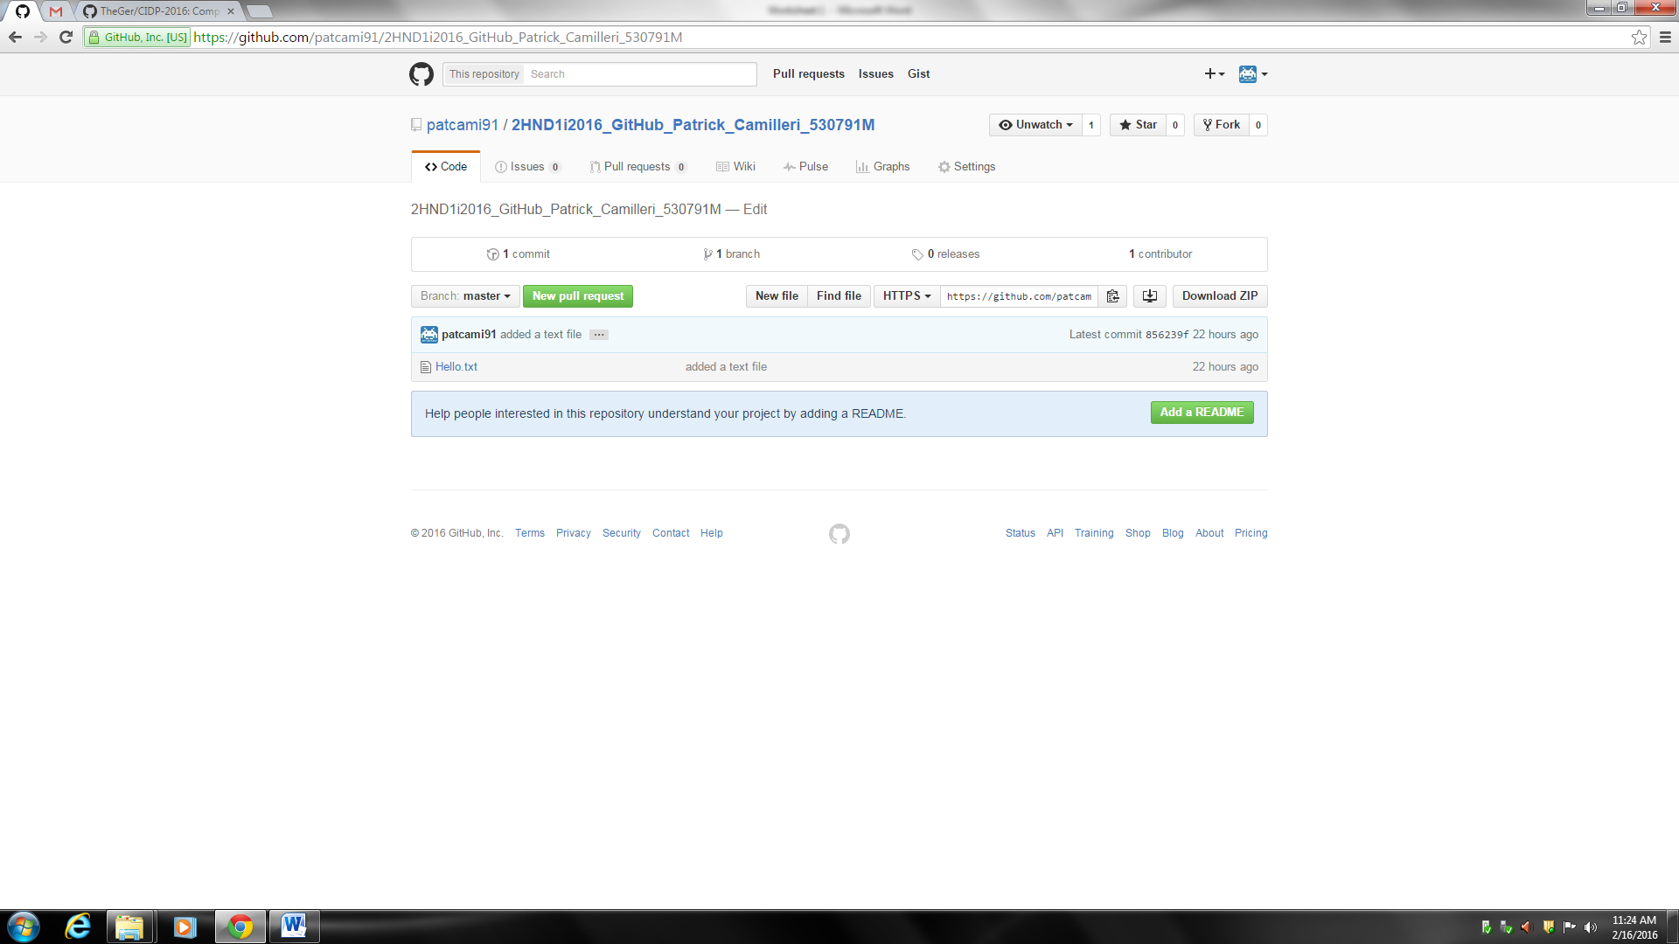

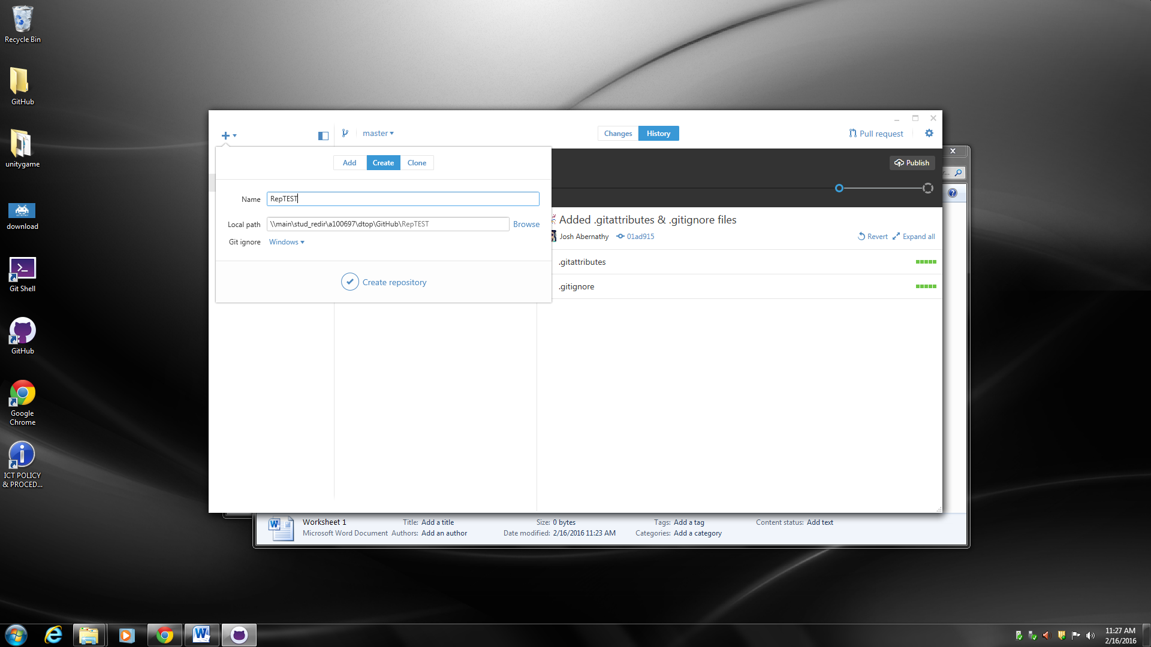

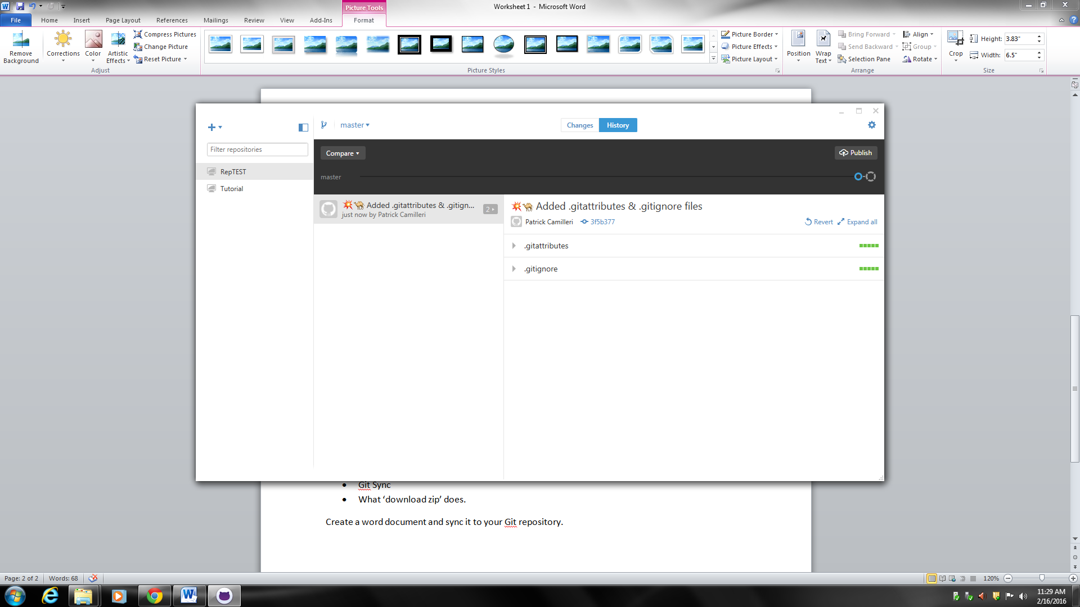

* Commit
* Commit description
* Github desktop
* Git Sync
* What ‘download zip’ does.

Create a word document and sync it to your Git repository.